Money Transfer — CSRF / IDOR
Proof of Concept Report — HackViser Lab
Prepared by: Aakash Singh | Date: May 31, 2026

Vulnerability Information

Author | Aakash Singh
Date | May 31, 2026
Lab | Money Transfer — CSRF / IDOR
Platform | HackViser
Vulnerability Type | CSRF / Insecure Direct Object Reference in Fund Transfer
Severity | Critical
CWE | CWE-352 / CWE-639
Impact
An attacker can craft a malicious URL that, when visited by a victim (or support agent), automatically triggers an unauthorized money transfer. This leads to financial loss and account compromise.
Reproduction Steps
Step 1: Log in to the application and check the account balance.
Step 2: Navigate to the money transfer feature and initiate a transfer to capture the request ID.
Step 3: Identify the transfer endpoint URL from Burp HTTP history.
Step 4: Craft a malicious URL using the captured transfer endpoint that sends money to the attacker account.
Step 5: Send the malicious URL to support (simulating a victim visit) — transfer is executed automatically.
Step 6: Retrieve the ID token confirming successful exploitation — lab solved.
Evidence Screenshots
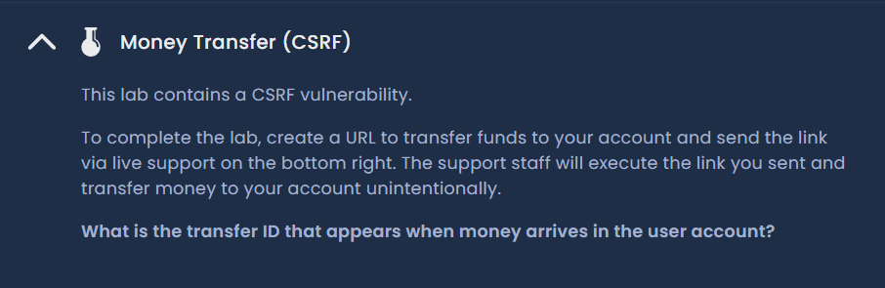
Figure 1: Account balance — initial state
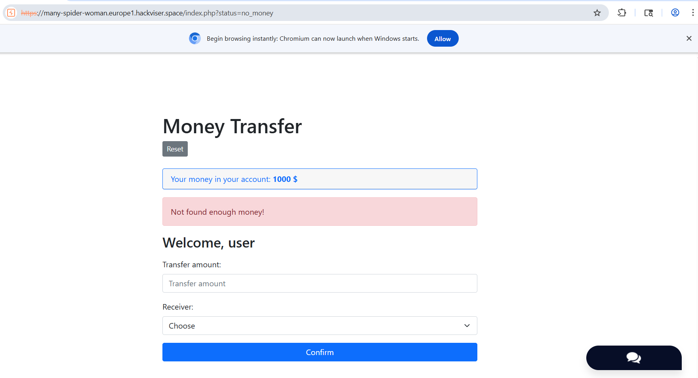
Figure 2: Money transfer initiation — capturing transfer request
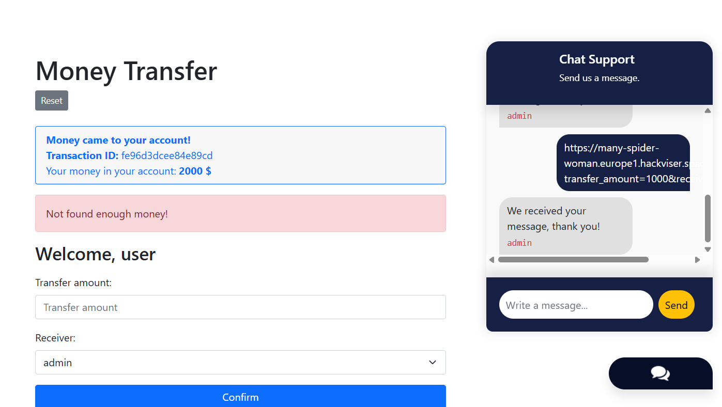
Figure 3: Transfer ID captured from HTTP history
Figure 4: Malicious URL crafted — ready to send to victim
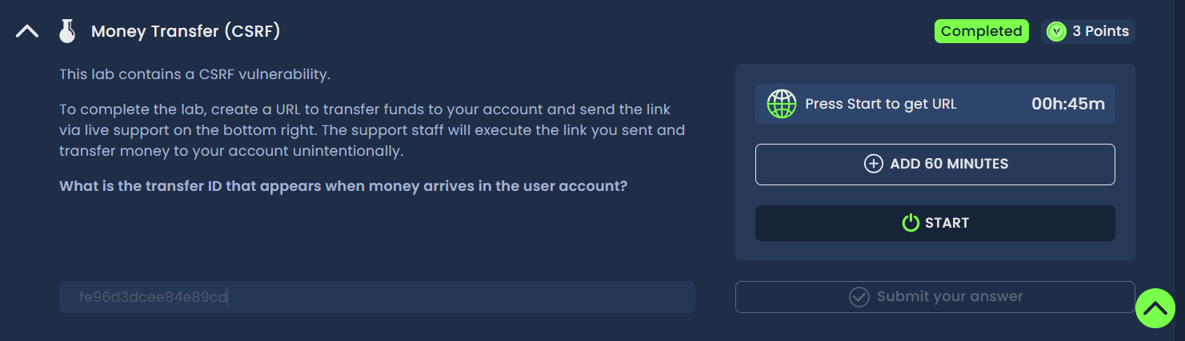
Figure 5: Lab solved — ID token retrieved, transfer confirmed
Remediation
Implement anti-CSRF tokens on all state-changing requests including fund transfers. Require re-authentication for financial operations. Validate that the transfer initiator is the authenticated account owner.
Confidential — Prepared by Aakash Singh | Security Research POC

